User List UI:
Under Action 3 dots, there will be the options like view details, Edit, Block, Delete,etc. Block/Delete action should work/execute without page redirection.

Reference UI
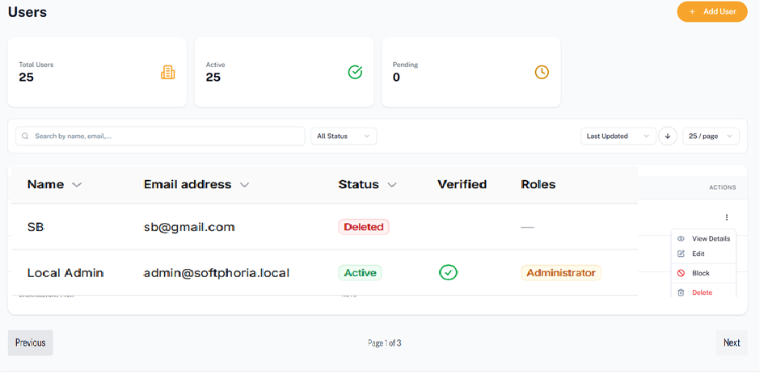

User Add/Edit Page: Prepare the Add/Edit/View page like the following one or more better.

